COMPUTING SUBJECT: VPN and other problems

TYPE: Assignment

IDENTIFICATION: VPNProblems

COPYRIGHT: Michael Claudius

LEVEL: Difficult to do, easy to understand

TIME CONSUMPTION: 2-10 hours

EXTENT: 50 lines

OBJECTIVE: Solving various issues

PRECONDITIONS: OpenVPN project
VPN Useful links

COMMANDS:

IDENTIFICATION: VPNProblems/MC

The Mission

There can be quite a lot of issues, when setting up OpenVPN. Help are given in this paper concerning:

Issue 1: Bridge or Net in Virtual box ?

Issue 2: Cannot find the correct IP address of the OpenVPN server

Issue 3: Can only see IP6-addresses not IP4-addesses

Issue 4: What is the VirtualBox IP address?

Issue 1: Bridge or Net in Virtual box ?
One must use the Bridge Adapter in VirtualBox.
In VirtualBox Manager Choose Settings -> Network

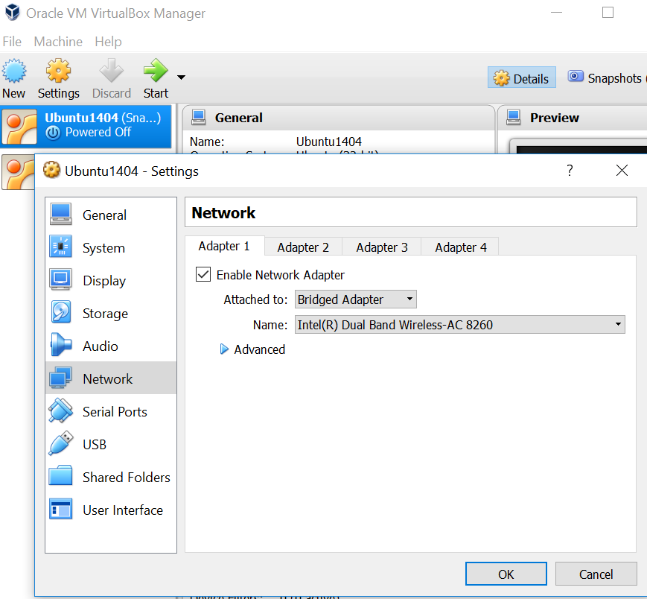

Tick Enable Network Adapter and choose Bridged Adapter.
Issue 2: Cannot find the correct IP address of the OpenVPN server
Remember VPN is a virtual network where both server and client is on the "same LAN" using the tunnels mode.
When you made openvpn rules allowing traffic from client to server you have given the identification of the vpn-server as eth0 or something similar in the file /etc/ufw/before.rules

# START OPENVPN RULES
# NAT table rules
*nat
:POSTROUTING ACCEPT [0:0]
# Allow traffic from OpenVPN client to eth0
-A POSTROUTING -s 10.8.0.0/8 -o eth0 -j MASQUERADE
COMMIT
# END OPENVPN RULES

Therefore the IP address is NOT the address of the VirtualBox adapter.
Start Ubuntu and open the Terminal Window.
Give the command:

ifconfig

You will get 3-4 adresses, look for the name of your server, mine was eth0.

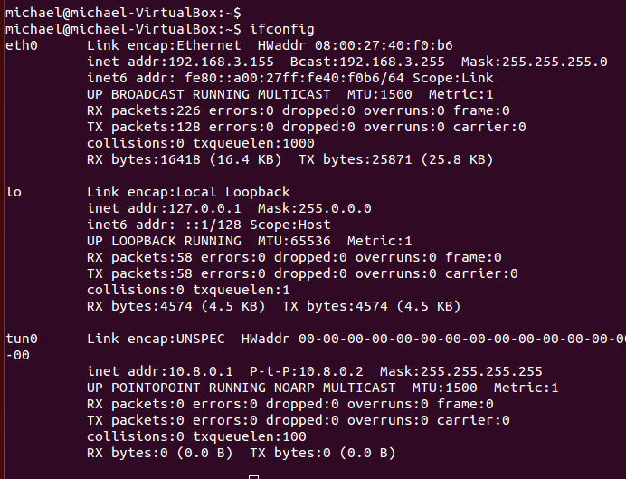

As seen eth0 has the IP address 192.168.3.155.
IF you only see IP6 addresses one will have to disable IP6 and enable IP4 addresses.
See next issue 3.
Issue 3: Can only see IP6-addresses not IP4-addesses
One will have to disable IP6 and enable IP4 addresses.
In Ubuntu Desktop Choose -> System Settings

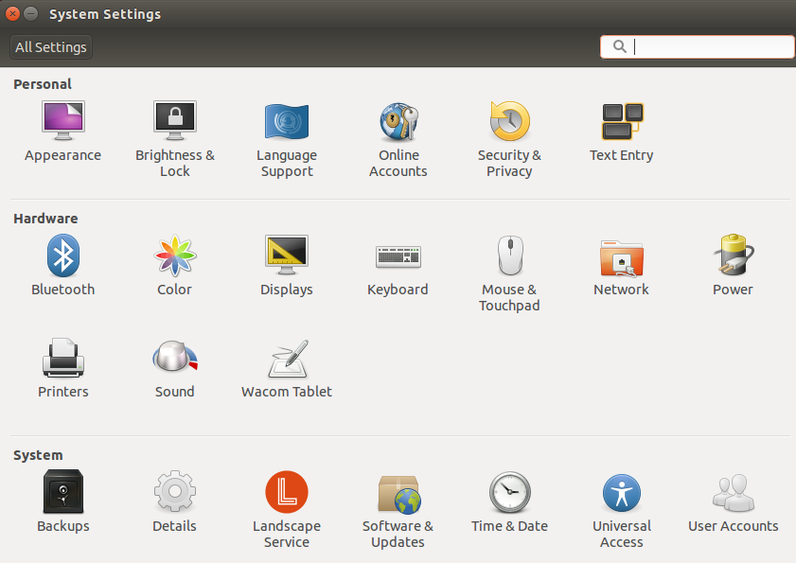

Choose: Network -> Options
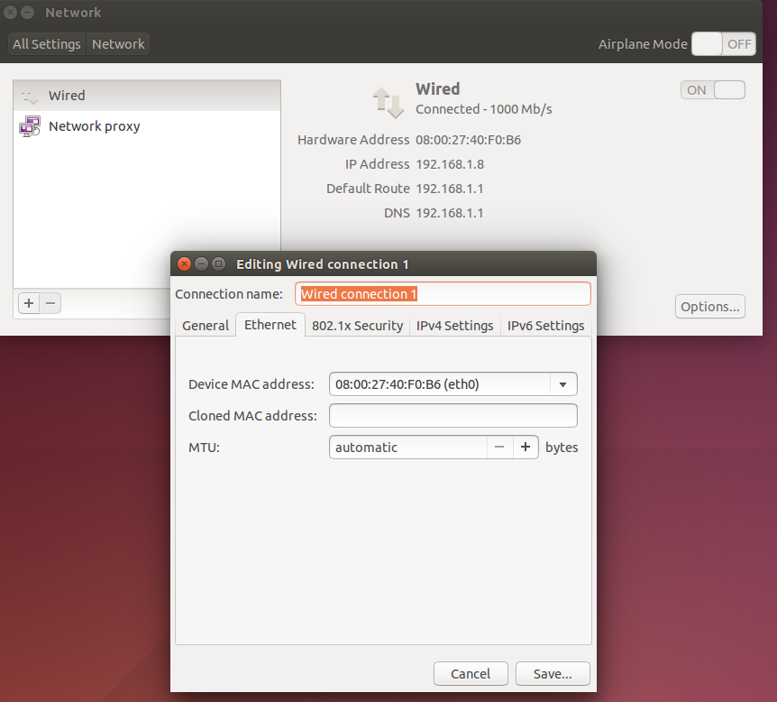

Click: IPv4 Settings and change the Method to Automatic(DHCP) and tick the box (red) for Require IPv4…...

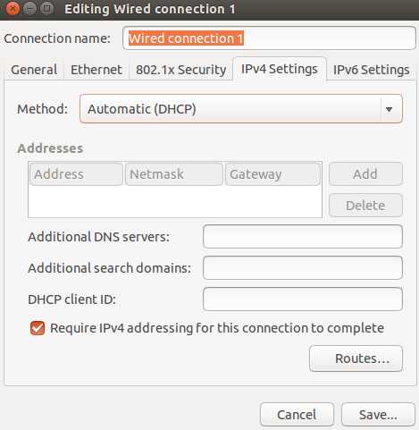

Click: IPv6 Settings and change the method to Ignore:

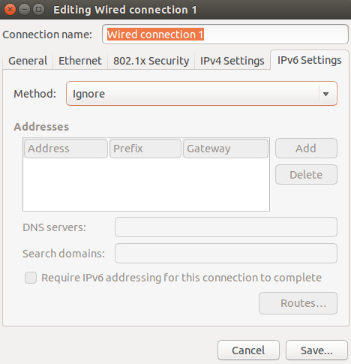

Click: Save

It can take a little time before settings have changed but try command ifconfig again.
If you cannot see the iPv4 address, then restart Ubuntu.
Alternatively change View to full screen mode and in the upper right corner select the Wifi symbol and click on Enable Networking and again click on Enable Networking.

Issue 4: What is the VirtualBox IP address?

Click Start -> Control Panel -> Betwork and Internet -> Network connections

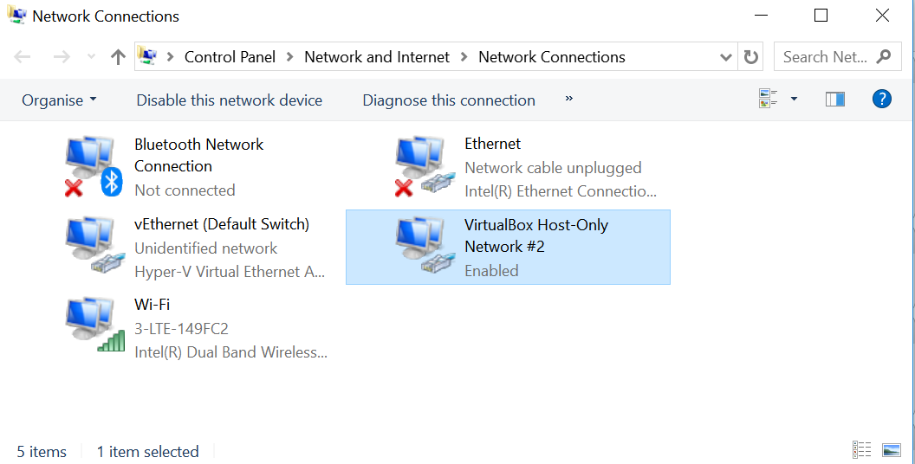

Click on VirtualBox adapter

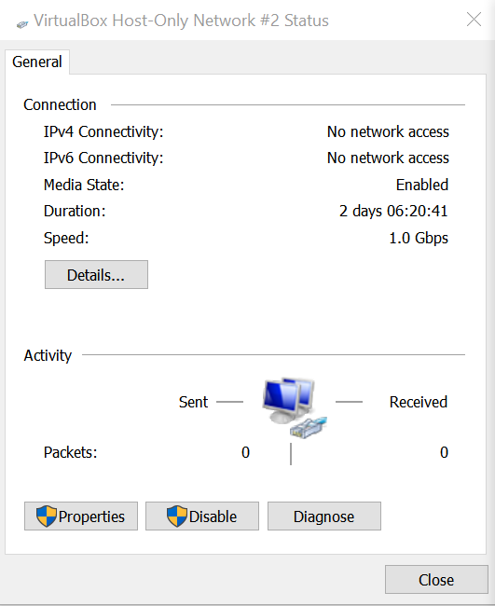

Click on Properties and you can see IPv4 address.

